SPI Protocol

SPI stands for the **Serial Peripheral Interface**. It is a serial communication protocol that is used to connect low-speed devices. It was developed by **Motorola** in the **mid-1980** for inter-chip communication. It is commonly used for communication with flash memory, sensors, real-time clock (RTC), analog-to-digital converters, and more. It is a full-duplex synchronous serial communication, which means that data can be simultaneously transmitted from both directions.

The main advantage of the SPI is to transfer the data without any interruption. Many bits can be sent or received at a time in this protocol.

In this protocol, devices are communicated in the master-slave relationship. The master device controls the slave device, and the slave device takes the instruction from the master device. The simplest configuration of the Serial Peripheral Interface (SPI) is a combination of a single slave and a single master. But, one master device can control multiple slave devices.

SPI Interface

The SPI protocol uses the four wires for the communication. There are shown in the figure.

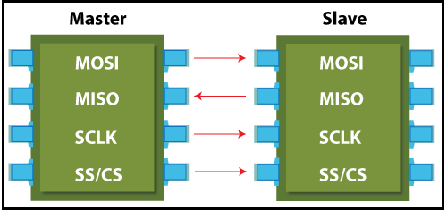

1. **MOSI:** MOSI stands for Master Output Slave Input. It is used to send data from the master to the slave.
2. **MISO:** MISO stands for Master Input Slave Output. It is used to send data from the slave to the master.
3. **SCK or SCLK (Serial Clock):** It is used to the clock signal.
4. **SS/CS (Slave Select / Chip Select):** It is used by the master to send data by selecting a slave.

Note: If the single slave is present in the communication, that required only three wires. The SS (slave select) is not required in it.

Advantages of SPI

1. The main advantage of the SPI is to transfer the data without any interruption.
2. It is simple hardware.
3. It provides full-duplex communication.
4. There is no need for a unique address of the slave in this protocol.
5. This protocol does not require precise oscillation of slave devices because it uses the master's clock.
6. In this, software implementation is very simple.
7. It provides high transfer speed.
8. Signals are unidirectional.
9. It has separate lines of MISO and MOSI, so the data can be sent and received at the same time.

Disadvantages of SPI

1. Usually, it supports only one master.
2. It does not check the error like the UART.
3. It uses more pins than the other protocol.
4. It can be used only from a short distance.
5. It does not give any acknowledgment that the data is received or not.

Applications of SPI

* Memory: SD Card, MMC, EEPROM, and Flash.
* Sensors: Temperature and Pressure.
* Control Devices: ADC, DAC, digital POTS, and Audio Codec.
* Others: Camera Lens Mount, Touchscreen, LCD, RTC, video game controller, etc.